**Object Oriented Programming with Java**

**TERMWORK**

1. Electricity Cost Estimate

Write a console-based java program to estimate electricity bill for a device based on

given user input. Take wattage of the device, number of usage hours/day from the user

Steps to calculate cost:

● Multiply the device’s wattage by the number of hours the appliance is used per day

● Divide by 1000

● Multiply by your kWh rate.

For example, if you have a 150-watt television that you watch five hours per day, it consumes 750 watt-hours per day (150 x 5 = 750). Divide 750 by 1000 to convert 750 watt-hours into 0.75 kWh (750 ÷ 1000 = 0.75). If your electricity rate is 70 paisa per kWh, that means it costs 525 Paisa per day to use your television (0.75 x 0.70 = 0.525). That should account for about Rs. 15.75 of your monthly electric bills (0.525 x 30 =15.75).

**Code:-**

import java.util.*;

class Prog1

{

public static void main(String args[])

{

double watt,hours,totupd;

double kwatt,totbpd,finalbill;

Scanner sc=new Scanner(System.in);

System.out.println("Please enter following details:");

System.out.println("Enter total Wattage of the device");

watt=sc.nextDouble();

System.out.println("Enter Hours/day You Are Using It");

hours=sc.nextDouble();

totupd=watt*hours;

System.out.println("Total Usge Of Entered Divice/per Is="+totupd);

kwatt=totupd/1000;

System.out.println("Total Usge Of Entered Divice/per

In kWattIs="+kwatt);

totbpd=kwatt*0.70;

totbpd=Math.round(totbpd * 1000.0) / 1000.0;

System.out.println("Total Bill For One Day Usage

As 0.70/Kwatt="+totbpd);

finalbill=totbpd*30;

System.out.println("");

System.out.println("");

System.out.println("--------------------Final Bill---------------------------");

System.out.println("Total Bill Per Month For This Device="+finalbill);

}

}

**Output:-**

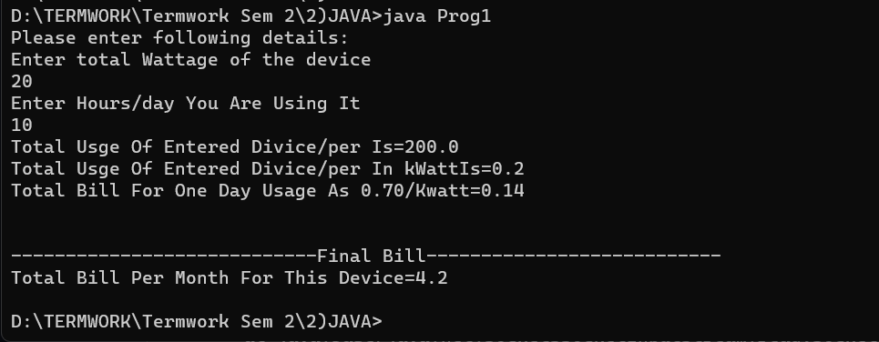

**2) Write a java program using socket for client server communication**

**Name : Prog2_server.**

import java.io.*;

import java.net.*;

public class Prog2_server {

public static void main(String[] args) throws IOException {

ServerSocket serverSocket = new ServerSocket(8080);

System.out.println("Your server is started on port (8080)");

Socket socket = serverSocket.accept();

DataInputStream dataInput = new DataInputStream(socket.getInputStream());

DataOutputStream dataOutputStream = new DataOutputStream(socket.getOutputStream());

String clientMessage = "";

while (!clientMessage.equals("exit")) {

clientMessage = dataInput.readUTF();

System.out.println("Client says: " + clientMessage);

dataOutputStream.writeUTF("Thank you : Your Message received");

dataOutputStream.flush();

}

dataInput.close();

socket.close();

serverSocket.close();

}

}

**Name : Prog2_client**

import java.io.*;

import java.net.*;

public class Prog2_client {

public static void main(String[] args) throws IOException {

Socket socket = new Socket("localhost", 8080);

DataInputStream datainput = new DataInputStream(socket.getInputStream());

DataOutputStream dataOutput = new DataOutputStream (socket.getOutputStream());

BufferedReader bufferedReader = new BufferedReader(new InputStreamReader(System.in));

String serverMessage = "";

String clientMessage = "";

while (!clientMessage.equals("exit")) {

clientMessage = bufferedReader.readLine();

dataOutput.writeUTF(clientMessage);

dataOutput.flush();

serverMessage = datainput.readUTF();

System.out.println("Server says: " + serverMessage);

}

dataOutput.close();

socket.close();

}

}

**Output:**



